Jack Spira
Notes Toward a Supreme Friction
Divine Speech in Sefer Yetzirah and Jābirean Takwīn
I will create as I speak.
Aryeh Kaplan, literal translation of ‘Abracadabra’

He who errs in this errs in all.
Jābir ibn Ḥayyān, Khitāb al-Aḥjār
Most if not all monotheistic traditions begin with and operate upon the understanding that all of creation as we know it results from a first, single cause, a god. But within such an understanding of the cosmos, how is our own role delimited, and in what endeavors are we overstepping our bounds? To answer this, I will here compare two works of great historical significance in the magical practices of monotheistic society: the ancient mystical text of the Sefer Yetzirah and selected writings by the early medieval alchemist Jābir ibn Ḥayyān.
Within their respective cosmologies, each work adopts a conspicuously phonetic approach to the practice of magic. Through an examination of the methods each applies to the act of anthropogenesis—golem-making in the Jewish tradition and takwīn (the alchemical creation of life) in the Islamic—and the historical context and legacy of each, we can begin to articulate an ethic of creation that unites the two works and the societies they inhabited. In the final analysis, we find a divergent reverence for the pursuit of knowledge, a shared wariness of the dangers of imitating god, and above all else a constant return to the power of speech.

The Sefer Yetzirah
Very little can be said precisely about the origins of the Sefer Yetzirah (Book of Creation). Rabbinic tradition commonly attributes its (oral) authorship and the teachings it contains to the partriarch Abraham, whose name appears in the final stanza of the book. By most estimates, scholarly and religious, the text was likely not committed to writing until sometime between the second and fifth centuries of the Christian era. This outside limit is when the first known quotation of the Yetzirah occurs, and the earliest commentary appears in the tenth century. With more than dozens of extant versions of the text, it is the most variant of Judaic written works.
The content of the Yetzirah is itself highly cryptic. In the introduction to his translation and commentary of the work, Torah and Kabbalah scholar Aryeh Kaplan classifies the Yetzirah as a primarily meditative treatise, but with a distinctly magical bent. The text itself classifies in various ways—and in terms more poetic than analytic—the letters of the Hebrew language. While it is often translated as an account of how god created the cosmos, Kaplan points out that the wording can more accurately be read in the imperative. Accordingly, Jewish lore and scholarly commentaries alike have portrayed the text as a manual for a sort of phonetic meditation on the names of god that, at a certain level of mastery, can bring about supernatural events.
Over the course of six chapters, the book variously categorizes, sexes, and permutes the twenty-two letters of the Hebrew alphabet. In no certain terms, it appears to establish an ontology linking various letters and combinations thereof with different modes, actual (in the case of the composition of the cosmos) or potential (of the levels of the soul), of being. These include direct correspondences to parts of the human body and other aspects of creation:
He made the letter Resh king over Peace
And He bound a crown to it
And He combined one with another
And with them He formed
Saturn in the Universe
Friday in the Year
The left nostril in the Soul,
male and female. (4:13)
Keeping in mind that the verse can also be read in the imperative (e.g. “Make the letter Resh… Bind a crown to it…”), we begin to see the makings of a sympathetic magic, by which concentration upon and manipulation of letters and sounds might allow one to alter natural events through a form of phonetic correspondence.
Such is the case with the making of a golem (an animated human form), the most advanced feat that could be accomplished with study of the Yetzirah. As an example of the meditative-magical character of the text, let us examine the recipe for golem-making given in one of the oldest extant commentaries on it, that of Rabbi Eliezer Rokeach of Wormes. Writing around the turn of the thirteenth century, Eliezer extrapolates upon the following verse:
He permuted them, weighed them, and transformed them,
Alef with them all
and all of them with Alef,
Bet with them all
and all of them with Bet.
They repeat in a cycle
and exist in 231 Gates.
It comes out that all that is formed
and all that is spoken
emanates from one Name. (2:5)
Extending the directive “Alef with all of them / and all of them with Alef” to the entire alphabet, we can understand the 231 Gates as a network of all the possible combinations of two letters from twenty-two (see fig. 1). A meditative chant was then constructed as follows. For each letter in such a combination, one would combine the letter with the first letter of the Tetragrammaton (the unutterable, four-letter name of god) and pronounce the two together with each of the five Hebrew vowels, and then proceed to the next letter in the name. Once all four letters of the name, in combination with the first letter in a pair, had been vocalized with each vowel, the same would be done with the second letter in the pair. This sequence (fig. 2) could be completed for as many pairs as desired.
In order to create a golem, one would, for each part of the body, take that part’s corresponding letter (say, Resh, for the left nostril), construct an array of 231 (or 221) pairs from it, and recite for each letter in the array the aforementioned sequence of vowels and letters of the Tetragrammaton, proceeding on to every letter in the alphabet and its corresponding body part. If one were to pronounce four syllables a second without rest, Kaplan calculates the process would last just under seven hours. To this phonetic recitation, Eliezer adds further ritual instructions, as paraphrased by Kaplan:
An initiate should not do it alone, but should always be accompanied by one or two colleagues. The Golem must be made of virgin soil, taken from a place where no man has ever dug. The soil must be kneaded with pure spring water, taken directly from the ground. If this water is placed in any kind of vessel, it can no longer be used. The people making the Golem must purify themselves totally before engaging in this activity, both physically and spiritually. While making the Golem, they must wear clean white vestments… one must not make any mistake or error in the

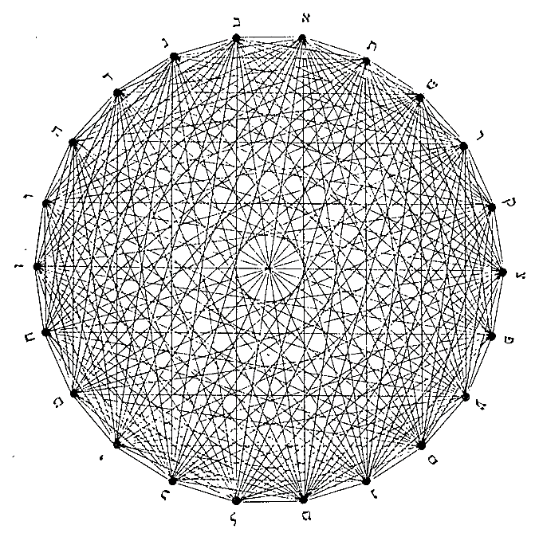
Figure 1. 22 points, 231 lines. The 231 lines connecting the 22 letters are the 231 Gates. Caption and diagram from Kaplan (fig. 18)

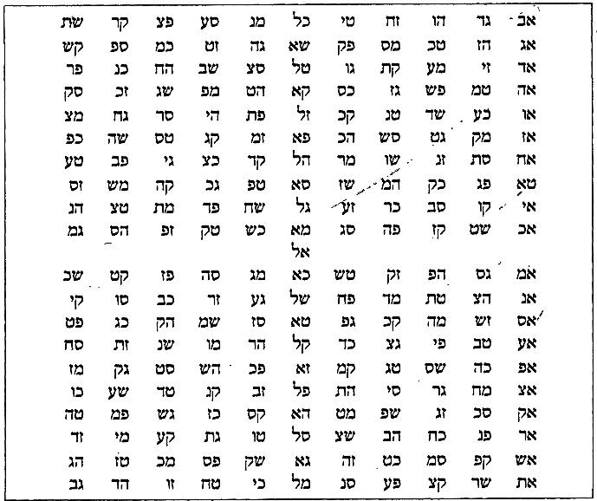
Figure 3. The 221 Gates according to Rabbi Eliezer Rokeach of Wormes (1160-1237). Caption and diagram from Kaplan (fig. 28)

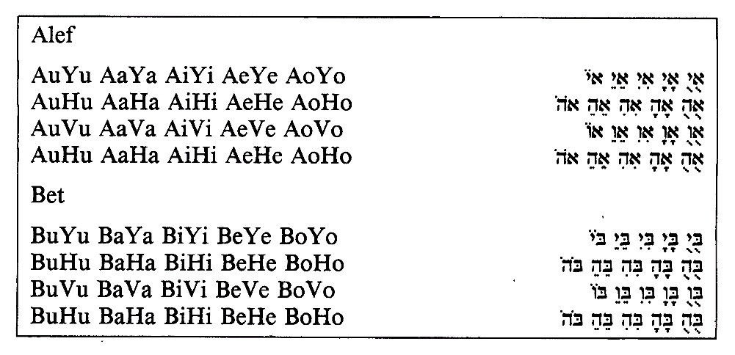
Figure 2. The sequence for Alef and Bet.
Caption and diagram from Kaplan (fig. 36)

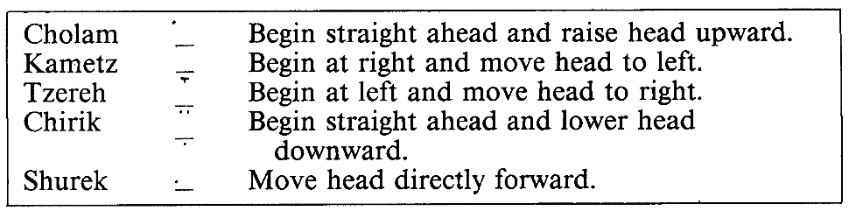
Figure 4. Abulafia's system of vowel motions.
Diagram from Kaplan (fig. 40)

pronunciation… During this entire procedure, no interruption
whatsoever may occur. (127)
The description of this ritual is notable for several reasons. First, the stipulation that one should never undertake the creation of a golem alone is echoed in a midrash (a rabbinic commentary, often unattributed) on Genesis 12:5 (see fn. 1) which emphasizes that the plural “they” in the scripture indicates that Abraham, too, employed collaborators in his magic. For if Abraham had attempted to create souls on his own, “he would have gone too far in emulating his Creator” (Kaplan xiii). This distancing of human actions from divine generation is highlighted in the very concept of yetzirah. Though often translated as ‘creation’ in the book’s title, yetzirah more precisely connotes ‘formation’, the composition of things from existing materials. It is different from b’riah, ‘creation’, which is usually attributed to god and from which derives the name for the biblical Book of Genesis.
However, Eliezer’s description also states that one must be completely pure of body and spirit in order to participate. If purity of spirit is taken to mean absence or absolution of all sin, we find a contradiction, or, at least, a complication. The Talmud, on the subject of golems, recounts the words of the Babylonian rabbi Rava:
If the righteous wish [to do so,] they [can] create a world, as it is stated: “But your iniquities have separated [between you and your God.” In other words, there is no distinction between God and a righteous person who has no sins, and just as God created the
world, so can the righteous.] (Sanhedrin 65b.16)
Indeed, the Talmud goes on to explain that “Rava created (b’riah) a man” and sent him to his friend Rabbi Zeira. The golem, however, couldn’t reply to Zeira in speech when questioned, a fact that the Sefer HaBahir takes to indicate that Rava was not perfectly sinless. Magic, therefore, must be performed in the liminal space between the fear of sinning by pretensions to divinity and the need for a prowess that one obtains by approaching it.
A chain of commentaries on a story from Genesis helps to shed light on the attitudes toward this ethical and psychological dilemma. Introducing Jacob’s son Joseph, the scripture relates that he brought to his father dibatam [defamations] on his brothers. Rashi, one of the most authoritative medieval commentators on Torah and Talmud, explains that these consisted of accusations “that they used to eat flesh cut off from a living animal, that they treated the sons of the handmaids with contempt, calling them slaves, and that they were suspected of living in an immoral manner” (37:2). Isaiah Horowitz, an early seventeenth century rabbi and Bohemian émigré to Palestine, rectifies the account by Rashi (eradicating its unseemly implications that either Joseph was a fantastic liar or else his brothers were monsters) in his Shenei Luḥot HaBerit (Two Tablets of the Covenant). Horowitz clarifies that the brothers, having learned the secrets of the Yetzirah from their father, the grandson of Abraham, likely used magic to create a golem calf from which they ate (thereby invalidating the laws regarding proper slaughter) and perhaps even golem women with which to pleasure themselves (Rashi’s “living in an immoral manner”). Regarding the accusation that they treated their half-brothers with contempt, Horowitz assures us that Joseph merely observed his brothers excluding from the mysteries of the Yetzirah these uninitiated sons of their father’s handmaids, since “secrets are not supposed to be handed to undeserving people” (Vayeshev 4).
Still unsatisfied with the play of events, early nineteenth-century German rabbi Moses Sofer goes further in his book Chiddushei Torat (Seal of the Scribe). Sofer for the most part concedes the plausibility of Horowitz’s suggestions, but outright denies they would have created women for their pleasure: “this I do not believe about the [progenitors of] the tribes of G-d… G-d forbid, G-d forbid”. Regarding their other actions, he asserts that Joseph in fact knew his brothers were using the Yetzirah yet—and here he draws attention to Rashi’s emphasis on the relationship of dibah to speech—reported their actions to Jacob because “their speech was evil—that they uttered with their lips holy names for their own purpose and not because of urgent need”. Jacob, in view of Joseph’s report, ceased to teach the mysteries to the brothers (Sofer writes “we do not give over divine names except to someone who is tzanuah [hidden, modest]”) but continued teaching these to Joseph. In the following verse, the scripture reads that Jacob gave Joseph a tunic of passim, sometimes translated ‘colors’ or ‘stripes’ or collectively as ‘ornate tunic’, yet Sofer points out that passim partly comprises the second-to-last word in the twenty-two-letter name of god. This Jacob taught Joseph, but stopped short of the final word—corresponding to the phrase in the priestly blessing “and He will grant you peace”—because he had not made peace with his brothers.
Taken in combination, Horowitz and Sofer, both respected voices in modern Jewish exegesis, give us deep insight into the ethics regarding use and teaching of the Yetzirah. Horowitz takes no umbrage at the possibility of the brothers creating women for their (ostensibly sexual) gratification, while Sofer balks at the idea, not only of the lewdness of the offense but also of using “holy names for their own purpose and not because of urgent need”. One’s motivations for employing the Yetzirah were perhaps of consequence. Of greater consequence, however, we find the two are closer to agreement on the matter of who is and is not permitted to perform such operations. The half-brothers of Joseph—the sons of his father’s maidservants, Bilhah and Zilpah—were of lesser pedigree (as Horowitz puts it, “of an inferior status”) and therefore ineligible, immutably, to partake of the mysteries of yetzirah. Sofer further suggests that, even if eligible by blood, one must be sufficiently tzanuah (hidden, modest) in the use of one’s powers in order to learn the mysteries, and, beyond that, must be at peace with one’s brothers.
Considering first these latter, contingent conditions for yetzirah, we find that Sofer’s insistence on being at peace recalls the specification in Eliezer that in order to create a golem an initiate must be totally purified. This emphasis on purity also appears in the Talmud, where, concerning the proscription against necromancy found in Deuteronomy 18:11, a distinction is made between spirits of impurity (used in raising the dead) and spirits of purity; Rava is said to have employed the latter in creating his golem. At the same time, we sense that purity can also be attained through use of the Yetzirah and the practices of meditation it prescribes. Kaplan writes of the golem-making procedure that, while accomplishing such a feat was a highly advanced, even dangerous endeavor, to be attempted only by the most disciplined practitioners, the sympathetic nature of the letters allowed one to heal or energize (in other words, purify physically and spiritually) individual parts of the body by reciting an array of its corresponding letter.
Contingent concerns aside, in order to practice the mysteries of the Yetzirah one first had to be initiated into them. Consequently, its use was often safeguarded through legal restrictions on how the text could be taught. The Talmud states that “the Divine Name must remain hidden. The Gemara relates: Rava planned to expound and explain the proper way to say the name in a public discourse. A certain elder said to him: It is written so that it can be read le’alem [to hide], indicating that it must stay hidden” (Kiddushin 71a.10). Guardedness concerning the teaching of the Yetzirah also figures heavily into its social history. Kaplan informs us that, from the sixth to tenth centuries, its instruction was restricted to several highly secretive rabbinic societies, some of which may have even produced deliberately corrupted versions of the text in order to mislead others, resulting in the many variants we have today. Even the golem recipe given by Eliezer, Kaplan tells us, is presented as an outline, and not intended as a complete and self-sufficient set of instructions.

Jābir ibn Ḥayyān
I turn now towards the philosophical and alchemical works of Jābir ibn Ḥayyān, a looming intellectual figure in the history of Islamic thought whose very historicity is hotly debated. The author attributed to a daunting corpus of some 3,000 works—treatises ranging over the disciplines of alchemy, astrology, chemistry, linguistics, mathematics, medicine, philosophy, physics, and theology, among others—Jābir is supposed by the latest scholarship to have lived and written early in the Abbasid caliphate (around the eighth or ninth century) in the area of Khurasan and Iraq, placing him right at the headwaters of Ismāʿīlī and Sufi thought. Some scholars, however, including the most extensive modern scholar of the Jābirean corpus, Paul Kraus, suppose these texts to have been penned by an entire school of writers over several generations. Some historical sources claim he studied as a disciple of the sixth Shiʿite Imam Jaʿfar al-Ṣādiq, and one anthology of Persian philosophy calls him nothing less than “the founder of Islamic alchemy and indirectly Latin alchemy” (Nasr and Aminrazavi 34).
Intellectual historian Syed Nomanul Haq, preceding his critical edition with translation and commentary of Jābir’s Kitāb al-Aḥjār ʿalā Raʾy Balīnās (Book of Stones According to the Opinion of Balīnās), elaborates upon the doctrinal context in which Jābir lived. As a philosopher, Haq explains, Jābir’s thought is more indebted to the Aristotelian than Hermetic elements of Neoplatonism, the dominant philosophical mode in the place and time of his writing, and yet departed from Aristotle in nontrivial ways. Jābir appears to have been deeply familiar with the works of Aristotle, and, while less evidence exists for his firsthand knowledge of certain seminal Neoplatonist philosophers (Plotinus, Proclus and Philoponus) he was decidedly aware of the works of Porphyry and Simplicius, and his own contributions seem to exist in concert with that school of thought. In fact, without mention anywhere in the corpus of Plotinus or his writings, Jābir’s cosmology seems to have been derived directly from the framework given by that philosopher. Haq writes:
In Jābir’s cosmology the universe is presented as a hierarchy of concentric spheres (aflāk, sing. falak) lying under the three Plotinian hypostases, the First Cause (= Demiurge-Creator, al-Bārī), Intelligence (al-ʿAql) and Soul (al-Nafs). The first sphere under the third hypostasis, which is often represented as a circle, is the one which embraces our world: “This circle is the Supreme Luminous Sphere, namely the one which embraces the world in which we are.” In fact, this Supreme Sphere, which is identified with the Ether, and which forms the boundary between the three hypostases and the natural world, is the World of Substance (ʿĀlam
al-Jawhar). (54-5)
Following the Neoplatonists, Jābir’s cosmology consists of an outwardly infinite demiurge emanating inwardly towards our material world, forming progressively more concrete and less divinely perfect levels of existence. The least of these is given by Soul (al-Nafs), within which the material realm exists.
Jābir incorporates Aristotle’s philosophy with the adoption of his four qualities: hot, cold, moist, and dry. Haq quotes Kraus as glossing the entire corpus with the paramount importance of this category: “the whole of Jābirean science reduces itself to the theory of qualities, their place and their combinations” (57). In Jābirean metaphysics, only after assuming various amounts of these qualities did substance become differentiated, corporeal, and sensible. Like substance, the qualities (or, sometimes, ‘natures’) were simple subjects, from which were constituted the compound elements (air, water, earth, and fire) or humors (black bile, yellow bile, blood, and phlegm). This constituted an essential departure from the Neoplatonist primacy of the elements, yet still endowed the qualities with physical mass. The qualities had to have weight, otherwise their combinations would produce nothing, and in Jābir’s philosophy they were the essential building blocks of all material reality.
All of these theoretical maneuvers, Haq tells us, were only of interest to Jābir as an alchemist, that is, only insofar as they yielded a practical framework for the study and manipulation of the natural world. He accordingly shapes this concept of the qualities into a system for taxonomical study built upon that of Galen, the ancient Greek physician. Extending (rather, refining) Galen’s crude compartmentalization of all materials into four degrees of intensity of four humors (for sixteen categories in total), Jābir separates each degree into seven subdivisions (yielding 112). To this he then applies the central concept of his philosophy, the science of balance, “whose aim was to reduce all facts of human knowledge to a system of quantity and measure” (67). (It is worth mentioning that Jābir’s Kitāb al-Aḥjār, to which we will turn shortly, is part of a collection of 144 treatises known as the Kutub al-Mawāzīn, or Books of Balances.) The science of balance could make apparent anything from the composition of the material world to the dynamics of the celestial bodies. Everything in the known universe is subject to the ‘supreme principle’ of balance, a fixed and divine ratio of the qualities (1 : 3 : 5 : 8). Where this ratio is observed, things exist in a structured equilibrium; without it, they disintegrate. It is from the principle of balance that alchemy is made possible; the person who can divine the composition of things and isolate their individual components is hence able to rearrange and transmute them.
But how to begin fitting material objects into a Galenic table? Jābir acknowledges the existence of many balances, and prioritizes above all others the balance of letters (also called the balance of articulation and the balance of utterance). By establishing that language inheres in reality, he effects a correspondence between the irreducible elements of language (letters or phonemes) and the irreducible elements of nature (the four qualities). Haq traces out the logic of this synthesis:
Language, he tells us, is an embodiment of what is represented in the intellect, and that which is represented in the intellect is the substance, essence and reality of being. Thus, language signified being, and since—by virtue of Jābir’s physical thesis—all naturally existing objects were reducible to the four natures, language signified the four natures. But language, like physical bodies, was ultimately reducible to primary elements—these elements were the primary units of speech represented by letters. Therefore, at the primitive level, (ideal) letters signified the natures. The ontological
equivalence of letters and natures was thereby established. (89-90)
With the metaphysical synthesis thus accomplished, Jābir then grants himself the entirety of language as the experimental subject for his algorithmic analysis, which he lays out and demonstrates in his Kitāb al-Aḥjār. By taking the name for a thing, reducing it to its root form, and computing the value of each letter (assigned to a degree by its position in the word) using the array previously described, one could discover the relative weights of the four qualities that
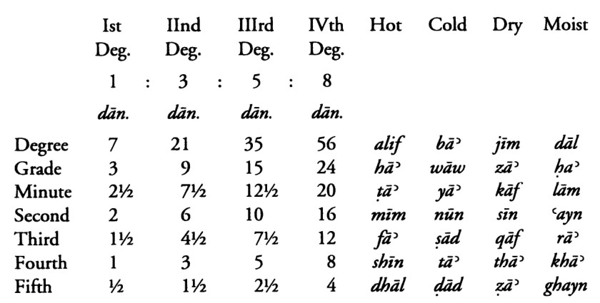
Figure 5. Jābir’s phonetic computer (dān. are a measure of weight). Taking the word USRUB (lead), and stripping away the redundant radical, we are left with alif – sīn – rāʾ – bāʾ. Plugging in each, we obtain 7 measures of hot, 6 of dry, 7½ of moist, and 56 of cold.
Table from Haq (p. 93)

comprise it (fig. 5). There remained many problems: the plurality of languages, the presence of homonyms, not to mention the existence of root words that contained more or less than four letters. His system is saved by a helpful panacea, a distinction between the latent (bāṭin) and manifest (ẓāhir) nature of things. In observing an object, we see only its manifest nature, from which, presupposing a balance of its qualities in the proper ratio, we can uncover that which is latent in it. This is the work of the alchemist, for if everything is constituted by the same structural relationships, then all instances of creation are organized by the same equilibrium—latent within water is fire; within lead, gold; within stones, people. stopped here
Takwīn, the alchemical creation of life, is of particular interest to Jābir, and appears throughout the corpus in recipes describing how to form scorpions, snakes, even human beings. It is important to recognize that takwīn, like yetzirah, connotes formation from existing material: “it is an act of creation which is through the intermediary of matter, time and motion and one which pre-supposes causal priority” (Dictionary of Islamic Philosophical Terms). It is not to be confused with ibdaʿ, which signifies creation ex nihilo. In her dissertation on the subject of takwīn in the Jābirean corpus, religious scholar Kathleen Malone O’Connor examines a strong historical precedent for the practice in ancient Egyptian vivification rituals, whereby the deceased, or statues of the gods, could be (re)animated through the use of spells and powerful words. She identifies a cosmological and methodological throughline from Egyptian to Hellenistic ritual, and, later, Hermetic and Arabic alchemy, which quite plausibly informed the Jābirean notion of takwīn. O’Connor then provides a translation of a recipe for the creation of a human being, as given in Jābir’s Kitāb Ustuqus al-Uss ʿalā Raʾy al-Diyāna wa Hūwa al-Thālith li Jābir (Book of the Element of the Foundation According to Religious Perspective, which is the Third of Three Parts by Jābir).
The stone from which the inner path comes into being is water in its appearance, but it is fire in its nature burning by its heat everything regarding its characteristics, so understand that. Only after your own experiential knowledge comes into being does the perfect nature come into existence from which is this work.
So divide it once in order to generate the upper body and lower body strata, and that which is high is purified and what remains is debased. And so, indeed, the upper division must be purified and is, thus, connected to what comes before it.
Then divide the lower impure portion so that it too becomes a higher portion and lower portion which is intensely dark. The earth is purified by means of water which becomes earthly in nature. And the earth is purified so that it becomes the brain. Then it is returned to the higher portion.
Then divide it [this resulting mixture of purified earth and the original higher portion] until you get again a higher and lower portion and purify the lower until it can no longer be consumed any further by fire. And purify this until it becomes fire. And let the fire continue for some time until it becomes the heart, liver, and arteries.
Let the earth continue to cook until it becomes spirit. And let the spirit continue until it becomes incandescent. And let the light continue until it becomes the pure white moon-like brain which does not include in it any of the fiery element. When you have thus achieved the brain, liver, and heart which is the pulsing artery, then join the brain to the liver and introduce the heart to them so that the heart becomes their organizer altogether and the organ which is awake to all things. Then you have completed a
perfect human being. (183-4).
The passage I excerpt follows the “inward mention of outward things, and outward mention of inward things, as well as mention of individual outward things” (182). The recipe for takwīn is subsequently given as a mention of individual inward things (cf. “the stone from which the inner path comes”). The creation of a human being is pure latency—a complete inversion of the stone, drawing fire from water—and therefore the most difficult feat of alchemy to accomplish. Nevertheless, the process Jābir outlines does not involve the separation of the latent from the manifest, as O’Connor reminds us, for the two are not only inseparable but representative of the dual nature of alchemy, both material and spiritual. Rather, it involves separation of the pure (‘higher’) from the impure (‘lesser’). Compare the quoted process, which highlights the importance of purification of the physical body part by part, with another (unquoted) aspect from Jābir’s introduction, which stresses the intense prerequisite intellectual refinement: “that which the seeker of this wisdom requires is patience over and above everything regarding the study of the sciences and then the study of our books regarding those sciences” (182).
Turning now to the historical reception of this sort of ritual, we will first consider Jābir himself. In the first two of the proceeding recipes/‘mentions’, Jābir prohibits anyone from altering the rites as he sets them forth. He also seems to imply that such rites must be learned from a teacher, or possibly performed with a peer: “we do not see regarding religion except through its revelation by one who is akin to us in purity of soul and acuteness of intellect” (182). In a broader perspective, Jābir also, as a matter of principle, openly engages in an esoteric practice he calls tabdīd al-ʿilm, the Principle of Dispersion of Knowledge. Throughout the corpus, he maintains the importance of never disclosing in full the meaning or execution of such knowledge, but of scattering it across a sufficiently wide array of works that the reader would have to perform a copious amount of research in order to derive a complete thought. This is in part intended to mislead those who shouldn’t be trusted with such knowledge.
Hence, O’Connor suggests that the process for takwīn may very well have consisted primarily of meditation or prayer—resulting in the formation of an astral projection, and not a physical one—with Jābir describing the process only in the broadest conceptual terms. She also gives a different justification for Jābir’s secrecy, citing Qu’ranic prohibitions against sorcery. On the other hand, many of these, she clarifies, specifically targeted pre-Islamic magical practices, and not takwīn as such, whereas the theory and practice of alchemy as Jābir and his followers knew it was in a sense inseparable from an orthodox religious perspective in medieval Islam. In distinguishing licit from illicit magic, she appeals to the authority of the Ikhwān al-Ṣafāʾ, who deem permissible magic that acts in the service of Islam, a subjective distinction to say the least. Practitioners of takwīn ran the risk of straying from this mandate: “imitation of the divine in the act of creating life comes perilously near what in Islam would be unbelief, that is, the association of anything with the matchless and inimitable powers of God” (22).

The Upshot
If I’ve abstained thus far from spelling out the conceptual connections between these two systems, do not misunderstand me: the extent of their similarities is astonishing. In light of the particular method of occlusion through which the Yetzirah was kept cloistered in various secret societies during Jābir’s lifetime (the Jābirean method of tabdīd al-ʿilm yields greater possibilities for textual familiarity), it appears rather unlikely that either borrowed directly from the other. Furthermore, each system in its practical dimensions is developed so cleanly upon its foundational metaphysics that even attempts to incorporate into one, via secondhand information, the practices of the other would appear grossly incongruous. (This last point relies upon the existence of differences between the two, and difference certainly exist, informing the unique flavor of each.) That we find, from Wormes to Khurasan, in divergent religious traditions driven ever further apart by the growing wedge of Christianity, multifaceted commonalities that go far beyond mere ubiquitous metaphors (i.e. the man made of clay), is something of a minor miracle. At the same time, there are pointed differences we must acknowledge, and not without consequence.
To (briefly) compare the foundational structures of the two, the Sefer Yetzirah and the Kitāb al-Aḥjār each outline a metaphysical system combining the letters of their respective languages with the composition of the cosmos. Their unique ways of modeling that cosmos differ (initially, at least, before the incorporation of Neoplatonist emanation to Kabbalistic thought in the early to high medieval period), but, according to each, specific applications of the metaphysical potential of letters can alter the events of the natural world. In the Yetzirah, it is the divine names alone that confer this power, and sympathetic magic occurs through meditation upon these in combination with other, disembodied letters, every one of which occupies part of a seemingly arbitrary network of correspondences. Jābir, on the other hand, finds latent power in the specific meaning of every name (known or imagined), and precisely in these meanings lie their correspondences.
Herein lies the greatest difference between the two: Jābir conceives his system as a science. It is admittedly a theoretical and not empirical science, but nevertheless a practice intended for the analysis of the material world and developed upon a program for the classification of medicinal simples. The Yetzirah could hardly be said to admit of a purpose, let alone a rigorously analytical one. The results of this difference are to be found in their perspectives on the pursuit and object of knowledge. Jābir’s objective is x-ray vision, an unimpeded view into the hidden nature of the entire observable galaxy and a technical mastery over it. The Kabbalists would have it otherwise, seeking instead to concentrate without distraction upon a single word until the thought of creation subsumes their being.
Conversely, in the fullest extent of the practices of these systems—golem-making with the Yetzirah, and takwīn for Jābir—we find their most salient commonality: the preponderance of the spoken word. Rabbi Eliezer tells us that a single mistake in the pronunciation of the arrays in the 231 Gates would require, at the very least, that one begin again from the start (hinting, even, at the actual perils that just such a mistake could pose). The performative element of Jābirean alchemy remains unclear, yet his entire lexical system depends crucially upon not the alphabetic but the phonetic signification of language. Through this aspect, we can better understand the ethical dilemma that faces the aspiring magician. To create the semblance of a person is to risk the unacceptable vanity of emulating god, who, as we have it from Genesis, also spoke creation into existence. Humankind is said to have been created in god’s image, yet the principal medium through which it has communicated with and accessed knowledge of god (and, thereby, of god’s mysteries) is through spoken language. In this manner, the sanctioned, perhaps mandated desire for thoroughgoing knowledge of god and all creation becomes the very motor by which we steer too close to becoming gods ourselves.
Works Cited
Haq, Syed Nomanul. Names, Natures and Things: the Alchemist Jābir ibn Ḥayyān and His Kitāb al-Aḥjār (Book of Stones). Kluwer Academic Publishers, 1994.
Horowitz, Isaiah. Shney Luchot Habrit. Translated by Eliyahu Munk, Lambda Pub, 1999, sefaria.org.
Kaplan, Aryeh. Sefer Yetzirah: the Book of Creation. S. Weiser, 1997.
Nasr, Seyyed Hossein, and Mehdi Aminrazavi. “Jābir Ibn Ḥayyān.” An Anthology of Philosophy in Persia, vol. 2, Oxford University Press, 2001, pp. 33–69.
O'Connor, Kathleen Malone. “The Alchemical Creation of Life (Takwīn) and Other Concepts of Genesis in Medieval Islam.” University of Pennsylvania, 1994.
Rosenbaum, M., et al., translators. Pentateuch, with Targum Onkelos, Haphtaroth and Prayers for Sabbath and Rashi's Commentary. Shapiro, Vallentine and Co., 1929, sefaria.org.
Sheikh, M. Saeed, and Alparslan Acikgenc. “Dictionary of Islamic Philosophical Terms.” Dictionary of Islamic Philosophical Terms, Islamic Philosophy Online, 4 Jan. 2008, www.muslimphilosophy.com/pd/.
Sofer, Moses. Chiddushei Torat. Translated by Gavriel Goldfeder [by special request of this author], 2018.
Steinsaltz, Adin Even-Israel, et al., editors. Koren Talmud Bavli, the Noé Edition. William Davidson digital edition, Shefa Foundation, 2015, sefaria.org.
Tanakh: the Holy Scriptures. Jewish Publ. Soc., 1988, sefaria.org.

The earliest example of this use of the text could have been by Abraham, as recounted in the ambiguous reference in Genesis 12:5 to the “souls that they [Abram, Sarai, and Lot] had made in Haran.” Typically, however, a golem is understood to be different from a “soul” in the sense of a bona fide human being, but rather an anthropomorphic creature that looks, acts, and possible even speaks like a one. As the third century Rabbi Elazar put it, “If all the people in the world came together, they could not create a gnat and imbue it with a soul” (xx). The first mention of a golem by name occurs in the Sefer HaBahir, a Kabbalistic text first published early in the twelfth century, in a commentary on the Talmud.
Eliezer, motivated by the Kabbalistic significance of the number 221 (which appears elsewhere in the Yetzirah) and seeking to improve upon earlier logical arrays of letters developed in the manner of the Gates, read 231 as 221 and removed ten redundant instances of the pair Alef-Lamed in order to produce his preferred array (fig. 3).
Another thirteenth century rabbi, Abraham Abulafia of Spain, constructed a system in which each pair (between a letter of the array and a letter of the name) should be pronounced in every possible permutation of letter and vowel ordering, lengthening the process tenfold, and, going further, imposed a metrical breathing pattern and system of head movements to be performed with each syllable (fig. 4).
Curiously—and this receives no mention by Kaplan—this is the word that appears in conjunction with Abraham in the final stanza, where it states, “He was successful in creation” (6:7). This use of the term perhaps excludes from golem-hood the “souls” they made in Haran, but conjures a whole mess of other theological complications.
See Haq, Names, Natures and Things (1994), Preface and Chapter I, and forward by David Pingree.
This is related to the Hebrew nefesh, which occurs in the Yetzirah and, as in the Jābirean system, denotes the lowest level of existence. Though a Neoplatonist influence on Jewish thought around the time of the Yetzirah’s writing is doubtful, it certainly appears to have made an impact on later Kabbalists, notable in the aforementioned Sefer HaBahir, and consequently on the cosmologies that have developed out of commentaries on the Yetzirah.
To Jābir, the basic elements of language were not written letters. Ideal language, from which all things derive names, is expressed only through vocal utterance, which is at best approximately represented by our written letters. In this he differs dramatically from the Ikhwān al-Ṣafāʾ (Brethren of Purity), an esoteric school of Islamic philosophers from the tenth century, who view Arabic as a divine, eternal language. Rather, Jābir sees written language as something always to be improved upon in our attempt to best represent ideal language. His alchemy, therefore, is an approximate science, but one that admits of the possibility for improvement as we calibrate our written language over time.
It is a small wonder, then, that Jābir is most explicit in specifying “a perfect human being” at the conclusion of his recipe. I propose that, his alchemy being an approximate science, based as it is on an imperfect alphabet, Jābir specifies ‘perfect’ knowing full well the impossibility of ever accomplishing as much, as if to say, “if one could do all this, as I’ve described it, one would have a perfect human being”. Else, he blasphemes. This notion recapitulates those Talmudic rabbis who asserted a person without sin could create a world.

